## Steps to update/upgrade session hosts for WVD Application Host Pool

Axalta publishes Remote Desktop/Applications via Windows Virtual Desktop to Users. Everyone Application is deployed using a Golden Image. The Golden Image is accessible to Application team to make required modifications/upgrade to Application binaries.

The Application team will make required changes to Golden Image on a periodic basis and request Virtualization/WVD Ops team to update the existing session hosts with the updated Golden Image so that those updates/upgrades can be delivered to end users.

Host Pool -

Below is the process to upgrade/update existing session hosts using Golden Image:-

### Take snapshot of the Golden Image’s OS & Data Disk.

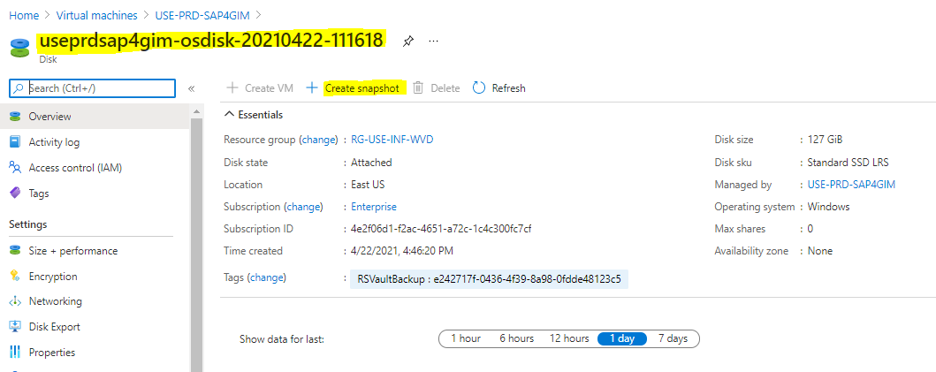

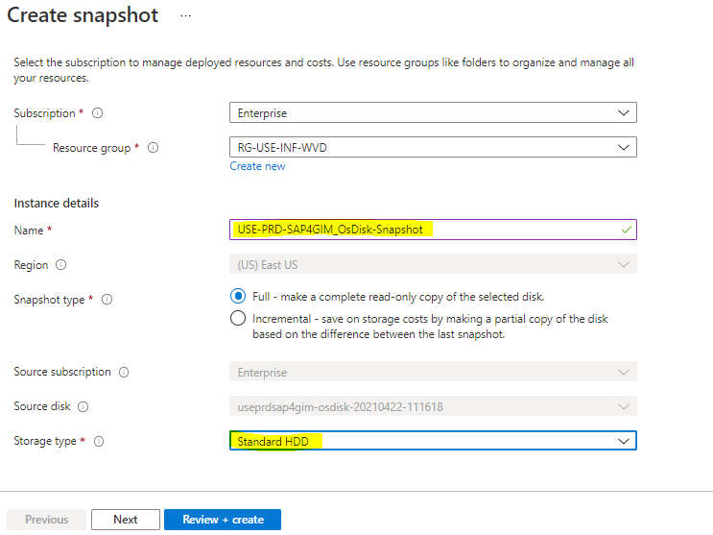

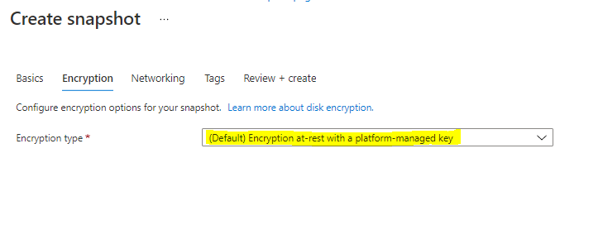

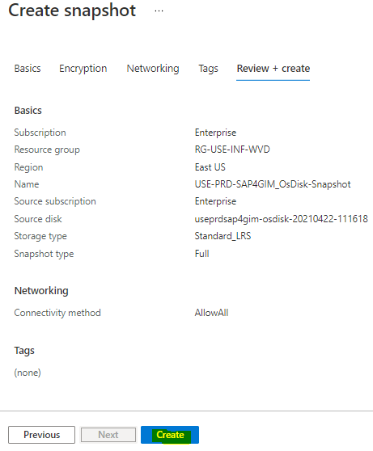

### Create a Managed disk from the Snapshot:-

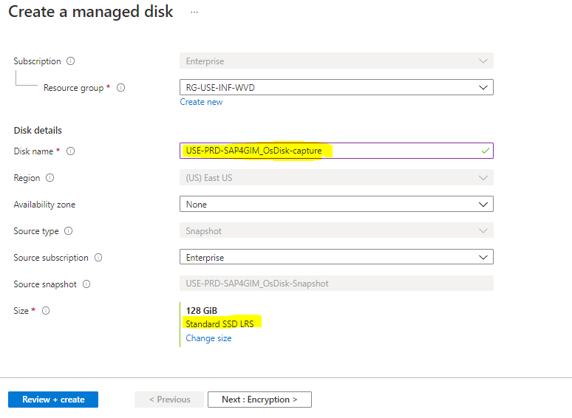

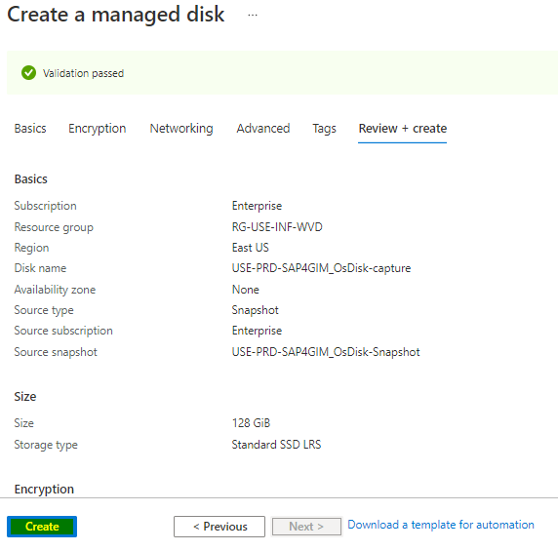

### Create a VM from the Managed Disk

**Shut Down Golden Image VM before Provisioning VM from managed disk created in above steps, to avoid NLA issue. ( before shutting down make sure to disjoin the Golden image from Domain)**

Note: The VM name must be GoldenimageName-image-date(YYYY-MM-DD). This VM will be discarded in the subsequent steps.

Make sure to provide below Storage account to the VM which is going to created for the Image for session hosts

we must choose the option “**Enable with Custom Storage Account**”

Select Diagnostic storage account from below list as per location and environment

following designated Storage Account to storage Boot Diagnostics Logs for Azure VMs in Enterprise Subscription:-

|  |  |  |  |
| --- | --- | --- | --- |
| **STORAGE ACCOUNT** | **RESOURCE GROUP** | **LOCATION** | **CREATED** |
| saeasdevbootdiag | rg-eas-inf-bootdiag | East Asia | 10/5/2020, 6:56:44 PM |
| saeasprdbootdiag | rg-eas-inf-bootdiag | East Asia | 10/5/2020, 6:56:30 PM |
| saeasqabootdiag | rg-eas-inf-bootdiag | East Asia | 10/5/2020, 6:56:55 PM |
| saneudevbootdiag | rg-neu-inf-bootdiag | North Europe | 10/5/2020, 7:09:49 PM |
| saneuprdbootdiag | rg-neu-inf-bootdiag | North Europe | 10/5/2020, 7:08:18 PM |
| saneuqabootdiag | rg-neu-inf-bootdiag | North Europe | 10/5/2020, 7:11:04 PM |
| saue2devbootdiag | rg-ue2-inf-bootdiag | East US 2 | 10/5/2020, 6:36:00 PM |
| saue2prdbootdiag | rg-ue2-inf-bootdiag | East US 2 | 10/5/2020, 6:33:56 PM |
| saue2qabootdiag | rg-ue2-inf-bootdiag | East US 2 | 10/5/2020, 6:38:49 PM |
| sausedevbootdiag | rg-use-inf-bootdiag | East US | 10/5/2020, 6:24:37 PM |
| sauseprdbootdiag | rg-use-inf-bootdiag | East US | 10/5/2020, 6:21:11 PM |
| sauseqabootdiag | rg-use-inf-bootdiag | East US | 10/5/2020, 6:26:39 PM |
| saussdevbootdiag | rg-uss-inf-bootdiag | South Central US | 10/5/2020, 6:49:57 PM |
| saussprdbootdiag | rg-uss-inf-bootdiag | South Central US | 10/5/2020, 6:49:50 PM |
| saussqabootdiag | rg-uss-inf-bootdiag | South Central US | 10/5/2020, 6:50:19 PM |
| sauw2devbootdiag | rg-uw2-inf-bootdiag | West US 2 | 10/5/2020, 6:43:57 PM |
| sauw2prdbootdiag | rg-uw2-inf-bootdiag | West US 2 | 10/5/2020, 6:43:17 PM |
| sauw2qabootdiag | rg-uw2-inf-bootdiag | West US 2 | 10/5/2020, 6:44:29 PM |
| saweudevbootdiag | rg-weu-inf-bootdiag | West Europe | 10/5/2020, 7:02:53 PM |
| saweuprdbootdiag | rg-weu-inf-bootdiag | West Europe | 10/5/2020, 7:02:42 PM |
| saweuqabootdiag | rg-weu-inf-bootdiag | West Europe | 10/5/2020, 7:03:03 PM |

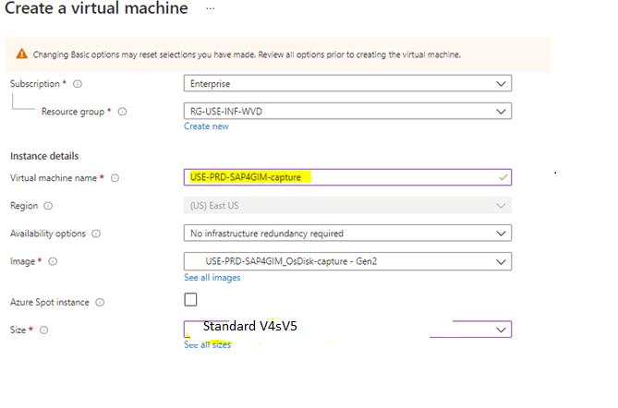

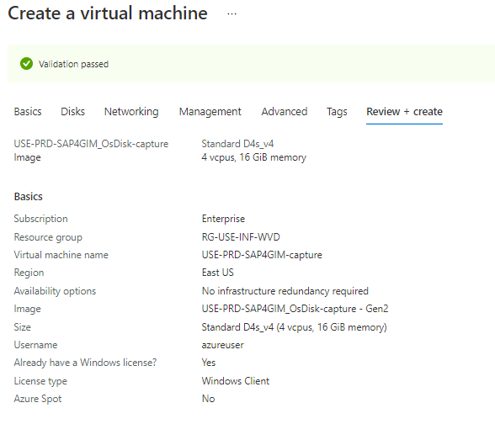

### Take a remote of the VM (created in the above step) and disjoin the VM from domain and change the VM name from inside OS similar to the VM name on Azure Portal.

### Validate for the presence of “Remote Desktop Agent & Boot Loader” from Appwiz.cpl. Remove, if present.

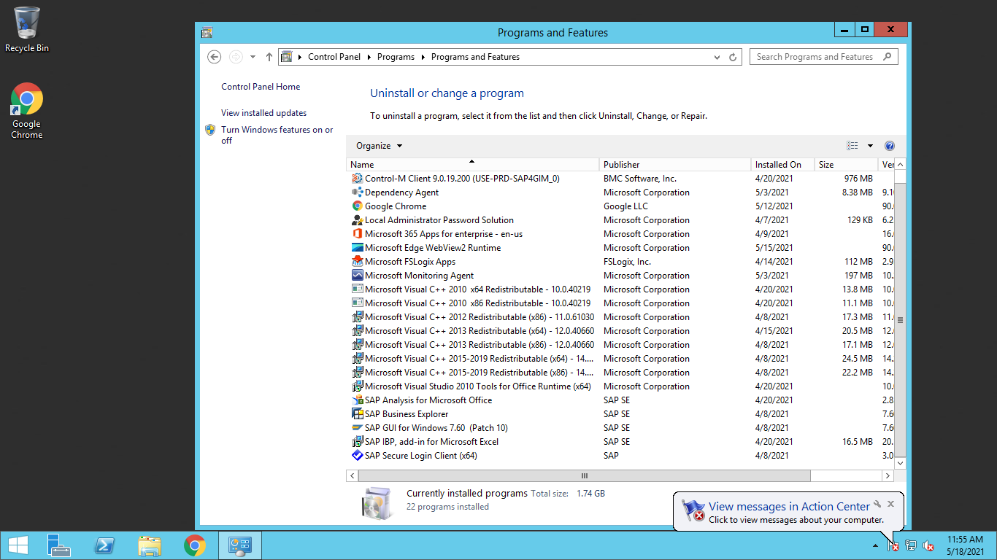

### Sysprep the VM (from OS)

**Note: Don’t forget to check Generalized options and Shutdown in Shutdown Options**

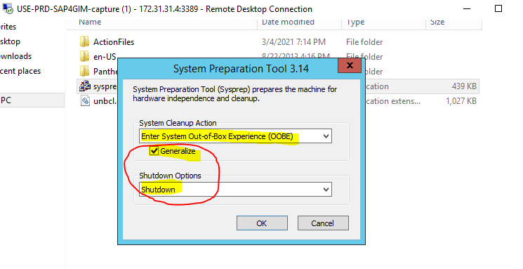

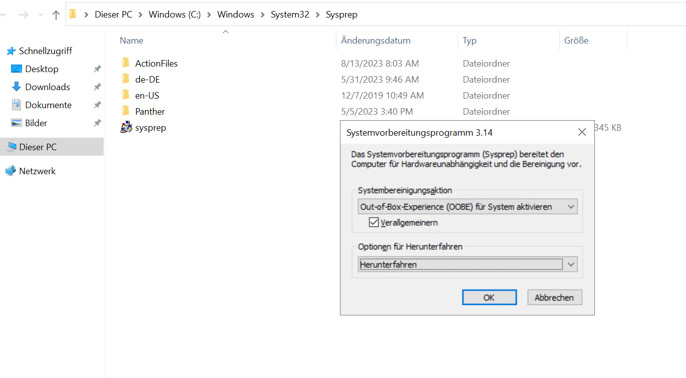

### Capture an image from this VM (**Do not Deallocate VM**)

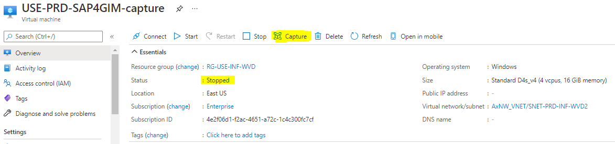

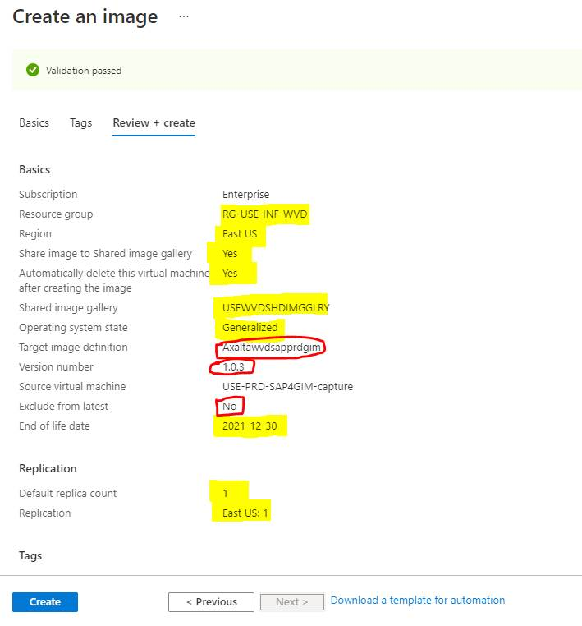

Must be no always

Depends on Application refer document

Depends on Application refer document

### Delete VM OS disk and NIC

After the image is captured from Azure portal, the VM is deleted. We need to make sure that we delete its OK disk and Network Interface Card from Azure Portal.

### Adding VM to the host pool

Navigate to the host pool where VM needs to be added and click on Add button. If recent activity of addition or removal of the VM is done before 15 days in the host pool. We need to regenerate certificate to proceed.

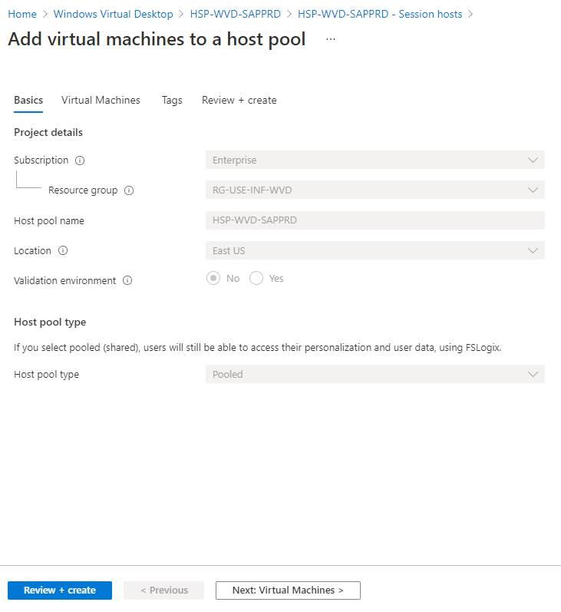

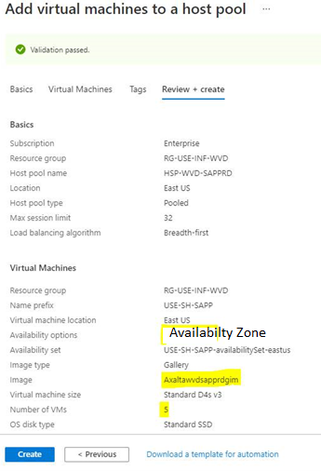

Number of the VMs as requested

Name of the Image Gallery depends on application

Name of the Availability Zone depends on application

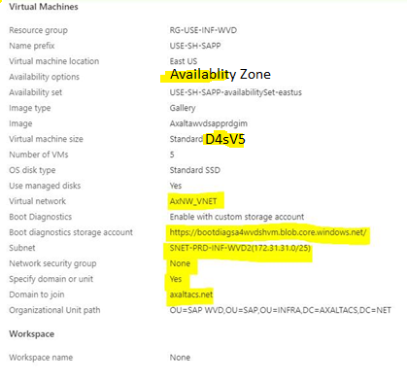

For path of the OU refer below

**General OU**

OU=WVD,OU=INFRA,DC=AXALTACS,DC=NET

**SAP Production OU information**

OU=SAP WVD,OU=SAP,OU=INFRA,DC=AXALTACS,DC=NET

**SAP QA OU information**

OU=SAP WVD,OU=SAP,OU=INFRA,DC=AXALTACSQA,DC=QA

**Note : You will not find the option to enable the Accelerated networking of Session host while creating / Adding it in Host pool . Once session host is created go to it Virtual machine blade and manually enable accelerated networking .**

**See below screen shot for reference :**

**Select Virtual machine , go to its networking blade , select Network Interface and then click on Edit accelerated networking .**

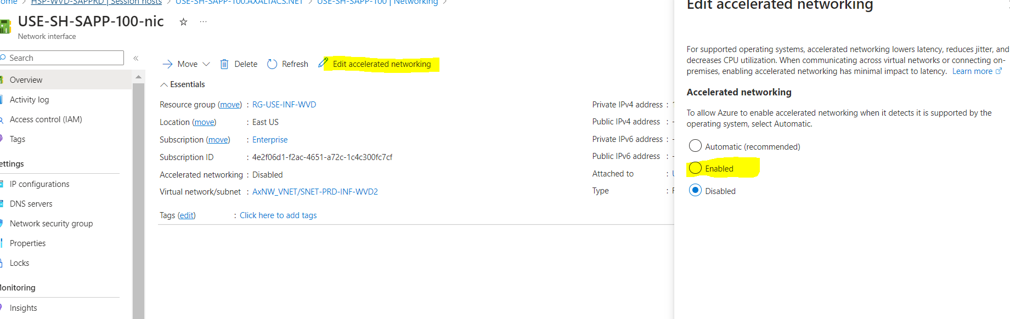

NOTE :

* If the Host pool where the Hosts will be used has a Scaling Plan, the Hosts must be created with configuration:
  + A new tag:     **avd-exclude-scaling-plan**  =  **true**    must be added to the hosts
  + Hosts must be configured then in “**Drained Mode**”

======================ISSUE

